Label Selector
https://kubernetes.io/docs/concepts/overview/working-with-objects/labels/

Equality (or) inequality-based
=,==,!=
kubectl get pods -l environment=production,tier=frontend

Set-based requirement
Newer resources, such as Job, Deployment, ReplicaSet, and DaemonSet, support set-based requirements as well.
in,notin and exists
kubectl get pods -l 'environment in (production),tier in (frontend)'
kubectl get pods -l 'environment in (production, qa)' – Production (or) qa

MatchLabels & MatchExpressions

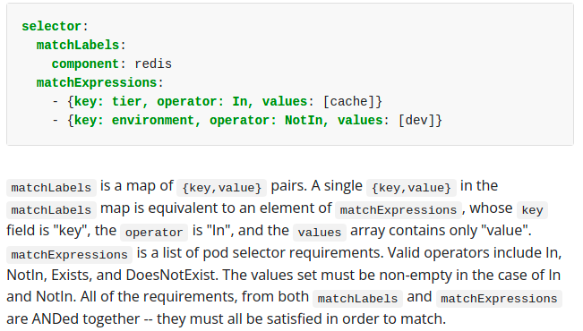
Annotations
You can use Kubernetes annotations to attach arbitrary non-identifying metadata to objects. Clients such as tools and libraries can retrieve this metadata.
Labels are for Kubernetes, while annotations are for humans.

Finalizers
Finalizers are namespaced keys that tell Kubernetes to wait until specific conditions are met before it fully deletes resources marked for deletion. Finalizers alert controllers to clean up resources the deleted object owned.
A common example of a finalizer is kubernetes.io/pv-protection, which prevents accidental deletion of PersistentVolume objects. When a PersistentVolume object is in use by a Pod, Kubernetes adds the pv-protection finalizer. If you try to delete the PersistentVolume, it enters a Terminating status, but the controller can't delete it because the finalizer exists. When the Pod stops using the PersistentVolume, Kubernetes clears the pv-protection finalizer, and the controller deletes the volume.

Recommended Labels
https://kubernetes.io/docs/concepts/overview/working-with-objects/common-labels/

Workloads
https://kubernetes.io/docs/concepts/workloads/

Deployment & ReplicaSet
Deployment is a good fit for managing a stateless application workload on your cluster, where any Pod in the Deployment is interchangeable and can be replaced if needed.

Updating Deployment
kubectl --record deployment.apps/nginx-deployment set image deployment.v1.apps/nginx-deployment nginx=nginx:1.16.1
updating deployment will delete existing pod & scale down replicaset(rs) & create new replicaset & pod on rolling update(By default, it ensures that at least 75% of the desired number of Pods are up (25% max unavailable))
Rollover & Rollback
You can specify the --record flag to write the command executed in the resource annotation kubernetes.io/change-cause. The recorded change is useful for future introspection. For example, to see the commands executed in each Deployment revision.

Rolled over new version:

k set image deploy/my-nginx <container_name>=nginx:1.161 -–record=true

Status: k rollout status deploy/my-nginx
History: k rollout history deploy/my-nginx

RollBack

k rollout undo deploy/my-nginx
kubectl rollout undo deployment.v1.apps/nginx-deployment --to-revision=2

Scaling a Deployment
kubectl scale deployment.v1.apps/nginx-deployment –replicas=10

Horizontal pod autoscaler
kubectl autoscale deployment.v1.apps/nginx-deployment --min=10 --max=15 –cpu-percent=80
kubectl get hpa --> list of all hpa

Rolling Update Deployment

Max Unavailable
.spec.strategy.rollingUpdate.maxUnavailable is an optional field that specifies the maximum number of Pods that can be unavailable during the update process.
For example, when this value is set to 30%, the old ReplicaSet can be scaled down to 70% of desired Pods immediately when the rolling update starts. Once new Pods are ready, old ReplicaSet can be scaled down further, followed by scaling up the new ReplicaSet, ensuring that the total number of Pods available at all times during the update is at least 70% of the desired Pods.

Max Surge
.spec.strategy.rollingUpdate.maxSurge is an optional field that specifies the maximum number of Pods that can be created over the desired number of Pods.
For example, when this value is set to 30%, the new ReplicaSet can be scaled up immediately when the rolling update starts, such that the total number of old and new Pods does not exceed 130% of desired Pods. Once old Pods have been killed, the new ReplicaSet can be scaled up further, ensuring that the total number of Pods running at any time during the update is at most 130% of desired Pods.
For example, If you were using the default values of 25% for both maxSurge and maxUnavailable, and applied an update to a Deployment with 8 pods, then maxSurge would be 2 pods, and maxUnavailable would also be 2 pods. That means that during the update process, the following conditions will be met:
- At most 10 pods (8 desired pods + 2 maxSurge pods) will be Ready during the update - MaxSurge
- At least 6 pods (8 desired pods - 2 maxUnavailable pods) will always be Ready during the update - MaxUnavailable

Replica set - Non-Template Pod acquisitions
While you can create bare Pods with no problems, it is strongly recommended to make sure that the bare Pods do not have labels which match the selector of one of your ReplicaSets. The reason for this is because a ReplicaSet is not limited to owning Pods specified by its template-- it can acquire other Pods in the manner specified in the previous sections.

StatefulSet
StatefulSet lets you run one or more related Pods that do track state somehow. For example, if your workload records data persistently, you can run a StatefulSet that matches each Pod with a PersistentVolume. Your code, running in the Pods for that StatefulSet, can replicate data to other Pods in the same StatefulSet to improve overall resilience.
Unlike a Deployment, a StatefulSet maintains a sticky identity for each of their Pods
StatefulSets are valuable for applications that require one or more of the following.
- Stable, unique network identifiers.
- Stable, persistent storage.
- Ordered, graceful deployment and scaling.
- Ordered, automated rolling updates.
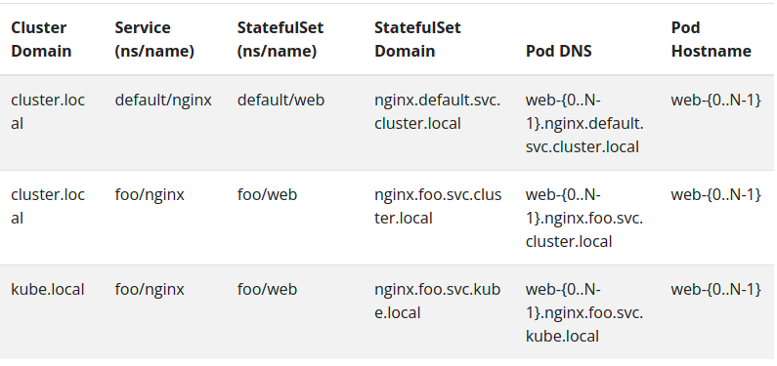
PersistentVolumes associated with the Pods' PersistentVolume Claims are not deleted when the Pods, or StatefulSet are deleted. This must be done manually.
When the nginx is created, three Pods will be deployed in the order web-0, web-1, web-2. web-1 will not be deployed before web-0 is Running and Ready, and web-2 will not be deployed until web-1 is Running and Ready. If web-0 should fail, after web-1 is Running and Ready, but before web-2 is launched, web-2 will not be launched until web-0 is successfully relaunched and becomes Running and Ready.
If a user were to scale the deployed example by patching the StatefulSet such that replicas=1, web-2 would be terminated first. web-1 would not be terminated until web-2 is fully shutdown and deleted. If web-0 were to fail after web-2 has been terminated and is completely shutdown, but prior to web-1's termination, web-1 would not be terminated until web-0 is Running and Ready.

DaemonSet
Defines Pods that provide node-local facilities. These might be fundamental to the operation of your cluster, such as a networking helper tool, or be part of an add-on. Every time you add a node to your cluster that matches the specification in a DaemonSet, the control plane schedules a Pod for that DaemonSet onto the new node.
Some typical uses of a DaemonSet are:
- running a cluster storage daemon on every node
- running a logs collection daemon on every node
- running a node monitoring daemon on every node

Deployments vs StatefulSets vs DaemonSets
https://medium.com/stakater/k8s-deployments-vs-statefulsets-vs-daemonsets-60582f0c62d4
Deployment | StatefulSet
Create Replica set(rs) | Doesn’t create replica set. StatefulSets don’t create ReplicaSet or anything of that sort, so you cant rollback a StatefulSet to a previous version. You can only delete or scale up/down the Statefulset
Name is of pattern - <name>-<rs-id>-<pod-id> | Name is of pattern - <name>-{0 to N-1}
All replicas of pods share one PVC | Each pod have its own PVC. If 3 pods are running, each have their own(3) pvc
 | PersistentVolumes associated with the Pods' PersistentVolume Claims are not deleted when the Pods, or StatefulSet are deleted
In Deployments, you can also manually roll back to a previous ReplicaSet, if needed in case if your new feature is not working as expected. | Rollback can’t be done here since rs isn’t created.

Job
Refer https://github.com/vinothg2309/kubernetes/jobs.yaml
define tasks that run to completion and then stop. Jobs represent one-off tasks, whereas CronJobs recur according to a schedule.
As pods successfully complete, the Job tracks the successful completions. When a specified number of successful completions is reached, the task (ie, Job) is complete. Pods (or) job isn’t removed by default when its completed. Deleting a Job will clean up the Pods it created. Suspending a Job will delete its active Pods until the Job is resumed again.

Job termination and cleanup
activeDeadlineSeconds applies to the duration of the job, no matter how many Pods are created.
There are situations where you want to fail a Job after some amount of retries due to a logical error in configuration etc. To do so, set .spec.backoffLimit to specify the number of retries before considering a Job as failed. The back-off limit is set by default to 6.

Clean up finished jobs automatically
TTL(Time To Live)
Finished Jobs are usually no longer needed in the system. Keeping them around in the system will put pressure on the API server. If the Jobs are managed directly by a higher level controller, such as CronJobs, the Jobs can be cleaned up by CronJobs based on the specified capacity-based cleanup policy.

Another way to clean up finished Jobs (either Complete or Failed) automatically is to use a TTL mechanism provided by a TTL controller for finished resources, by specifying the .spec.ttlSecondsAfterFinished field of the Job. When the TTL controller cleans up the Job, it will delete the Job cascadingly, i.e. delete its dependent objects, such as Pods, together with the Job. Note that when the Job is deleted, its lifecycle guarantees, such as finalizers, will be honored.

CronJob
Refer https://github.com/vinothg2309/kubernetes/Cron-Jobs.yaml
A CronJob creates Jobs on a repeating schedule. All CronJob schedule: times are based on the timezone of the kube-controller-manager.
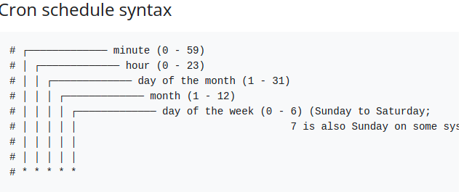

CleanUp
The .spec.successfulJobsHistoryLimit and .spec.failedJobsHistoryLimit fields are optional. These fields specify how many completed and failed jobs should be kept. By default, they are set to 3 and 1 respectively. Setting a limit to 0 corresponds to keeping none of the corresponding kind of jobs after they finish.

Pods

Life Cycle

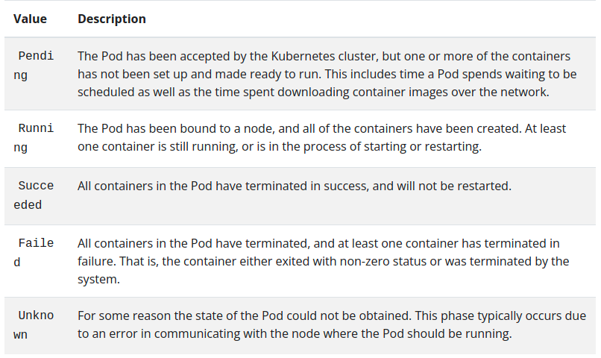
Init Containers
A Pod can have multiple containers running apps within it, but it can also have one or more init containers, which are run before the app containers are started.
Init containers are exactly like regular containers, except:
- Init containers always run to completion.
- Each init container must complete successfully before the next one starts.
If a Pod's init container fails, the kubelet repeatedly restarts that init container until it succeeds. However, if the Pod has a restartPolicy of Never, and an init container fails during startup of that Pod, Kubernetes treats the overall Pod as failed.
apiVersion: v1
kind: Pod
metadata:
name: myapp-pod
labels:
app: myapp
spec:
containers:
- name: myapp-container
image: busybox:1.28
command: ['sh', '-c', 'echo The app is running! && sleep 3600']
initContainers:
- name: init-myservice
image: busybox:1.28
command: ['sh', '-c', "until nslookup myservice.$(cat /var/run/secrets/kubernetes.io/serviceaccount/namespace).svc.cluster.local; do echo waiting for myservice; sleep 2; done"]
- name: init-mydb
image: busybox:1.28
command: ['sh', '-c', "until nslookup mydb.$(cat /var/run/secrets/kubernetes.io/serviceaccount/namespace).svc.cluster.local; do echo waiting for mydb; sleep 2; done"]

Container states
To check the state of a Pod's containers, you can use kubectl describe pod <name-of-pod>. The output shows the state for each container within that Pod.

Waiting:
If a container is not in either the Running or Terminated state, it is Waiting

Running
The Running status indicates that a container is executing without issues. If there was a postStart hook configured, it has already executed and finished.

Terminated
A container in the Terminated state began execution and then either ran to completion or failed for some reason. If a container has a preStop hook configured, that runs before the container enters the Terminated state.

Container probes

1. LivenessProbe
Indicates whether the container is running. If the liveness probe fails, the kubelet kills the container, and the container is subjected to its restart policy. If a Container does not provide a liveness probe, the default state is Success.

2. ReadinessProbe
Indicates whether the container is ready to respond to requests. If the readiness probe fails, the endpoints controller removes the Pod's IP address from the endpoints of all Services that match the Pod. The default state of readiness before the ial delay is Failure. If a Container does not provide a readiness probe, the default state is Success.

3. StartupProbe
Indicates whether the application within the container is started. All other probes are disabled if a startup probe is provided, until it succeeds. If the startup probe fails, the kubelet kills the container, and the container is subjected to its restart policy.

Containers
https://kubernetes.io/docs/concepts/workloads/pods/ -containers/
A Pod can have multiple containers running apps within it, but it can also have one or more containers, which are run before the app containers are started.

Ephemeral Containers
Special type of container that runs temporarily in an existing Pod to accomplish user- iated actions such as troubleshooting. You use ephemeral containers to inspect services rather than to build applications.

Container cmd & args
https://kubernetes.io/docs/tasks/inject-data-application/define-command-argument-container/
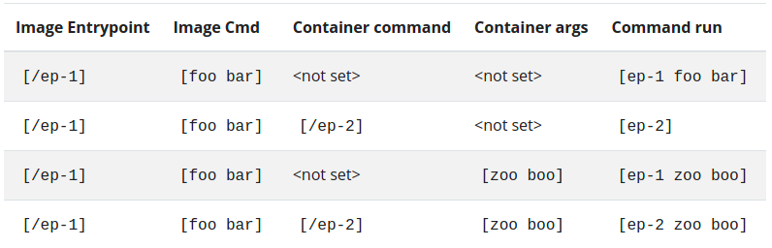

Services
An abstract way to expose an application running on a set of Pods as a network service. With Kubernetes you don't need to modify your application to use an unfamiliar service discovery mechanism. Kubernetes gives Pods their own IP addresses and a single DNS name for a set of Pods, and can load-balance across them.

Services without selectors
Services most commonly abstract access to Kubernetes Pods, but they can also abstract other kinds of backends. For example:
- You want to have an external database cluster in production, but in your test environment you use your own databases.
- You want to point your Service to a Service in a different Namespace or on another cluster.
- You are migrating a workload to Kubernetes. While evaluating the approach, you run only a portion of your backends in Kubernetes.

Because this Service has no selector, the corresponding Endpoints object is not created automatically by Endpoint controller in master’s controller component. You can manually map the Service to the network address and port where it's running, by adding an Endpoints object manually:
apiVersion: v1
kind: Endpoints
metadata:
name: my-service
subsets:
- addresses:
- ip: 192.0.2.42
ports:
- port: 9376

Discovering services

Environment variables
When a Pod is run on a Node, the kubelet adds a set of environment variables for each active Service. It supports both Docker links compatible variables (see makeLinkVariables) and simpler {SVCNAME}_SERVICE_HOST and {SVCNAME}_SERVICE_PORT variables, where the Service name is upper-cased and dashes are converted to underscores.
When you have a Pod that needs to access a Service, and you are using the environment variable method to publish the port and cluster IP to the client Pods, you must create the Servicebefore the client Pods come into existence. Otherwise, those client Pods won't have their environment variables populated.

DNS
A cluster-aware DNS server, such as CoreDNS, watches the Kubernetes API for new Services and creates a set of DNS records for each one. If DNS has been enabled throughout your cluster then all Pods should automatically be able to resolve Services by their DNS name.
For example, if you have a Service called my-service in a Kubernetes namespace my-ns, the control plane and the DNS Service acting together create a DNS record for my-service.my-ns. Pods in the my-ns namespace should be able to find the service by doing a name lookup for my-service (my-service.my-ns would also work).
Kubernetes offers a DNS cluster addon Service that automatically assigns dns names to other Services. You can check if it's running on your cluster:
kubectl get services kube-dns --namespace=kube-system

Headless Services
Sometimes you don't need load-balancing and a single Service IP. In this case, you can create what are termed "headless" Services, by explicitly specifying "None" for the cluster IP (.spec.clusterIP).
For headless Services, a cluster IP is not allocated, kube-proxy does not handle these Services, and there is no load balancing or proxying done by the platform for them.
You can use a headless Service to interface with other service discovery mechanisms, without being tied to Kubernetes' implementation.

With selectors
For headless Services that define selectors, the endpoints controller creates Endpoints records in the API, and modifies the DNS configuration to return A records (IP addresses) that point directly to the Pods backing the Service.

Without selectors
For headless Services that do not define selectors, the endpoints controller does not create Endpoints records. However, the DNS system looks for and configures either:
- CNAME records for ExternalName-type Services.
- A records for any Endpoints that share a name with the Service, for all other types.
If we don’t have selector in service, Endpoint controller won’t create endpoints. It applies for both headless (or) normal service.

Service Types

ClusterIP
Exposes the Service on a cluster-internal IP. Choosing this value makes the Service only reachable from within the cluster. This is the default ServiceType.

NodePort
Exposes the Service on each Node's IP at a static port (the NodePort). A ClusterIP Service, to which the NodePort Service routes, is automatically created. You'll be able to contact the NodePort Service, from outside the cluster, by requesting <NodeIP>:<NodePort>. Default: 30000-32767.
LoadBalancer
Exposes the Service externally using a cloud provider's load balancer. NodePort and ClusterIP Services, to which the external load balancer routes, are automatically created.

ExternalName

Maps the Service to the contents of the externalName field(e.g. foo.bar.example.com), by returning a CNAME record with its value. No proxying of any kind is set up.

Storage
On-disk files in a container are ephemeral, which presents some problems for non-trivial applications when running in containers. One problem is the loss of files when a container crashes.

Volume
Volume decouples the storage from the Container. Its lifecycle is coupled to a pod. It enables safe container restarts and sharing data between containers in a pod.
You create a Pod that runs one Container. This Pod has a Volume of type emptyDir that lasts for the life of the Pod, even if the Container terminates and restarts.
apiVersion: v1
kind: Pod
metadata:
name: redis
spec:
containers:
- name: redis
image: redis
volumeMounts:
- name: redis-storage
mountPath: /data/redis
volumes:
- name: redis-storage
emptyDir: {}

PersistentVolume
A PersistentVolume (PV) is a piece of storage in the cluster that has been provisioned by an administrator or dynamically provisioned using Storage Classes. It is a resource in the cluster just like a node is a cluster resource. PVs are volume plugins like Volumes, but have a lifecycle independent of any individual Pod that uses the PV.
apiVersion: v1
kind: PersistentVolume
metadata:
name: task-pv-volume
labels:
type: local
spec:
accessModes:
- ReadWriteOnce
storageClassName: manual
capacity:
storage: 10Gi
hostPath:
path: "/mnt/data"

Provisioning

Static
A cluster administrator creates a number of PVs. They carry the details of the real storage, which is available for use by cluster users. They exist in the Kubernetes API and are available for consumption.

Dynamic
When none of the static PVs the administrator created match a user's PersistentVolumeClaim, the cluster may try to dynamically provision a volume specially for the PVC. This provisioning is based on StorageClasses: the PVC must request a storage class and the administrator must have created and configured that class for dynamic provisioning to occur. Claims that request the class "" effectively disable dynamic provisioning for themselves.

PersistentVolumeClaim
A PersistentVolumeClaim (PVC) is a request for storage by a user. It is similar to a Pod. Pods consume node resources and PVCs consume PV resources. Pods can request specific levels of resources (CPU and Memory). Claims can request specific size and access modes (e.g., they can be mounted ReadWriteOnce, ReadOnlyMany or ReadWriteMany, see AccessModes).
Remember as “ASRRS” in spec
apiVersion: v1
kind: PersistentVolumeClaim
metadata:
name: task-pv-claim
spec:
accessModes:
- ReadWriteOnce
storageClassName: manual
resources:
requests:
storage: 3Gi

Storage Object in Use Protection
If a user deletes a PVC in active use by a Pod, the PVC is not removed immediately. PVC removal is postponed until the PVC is no longer actively used by any Pods. Also, if an admin deletes a PV that is bound to a PVC, the PV is not removed immediately. PV removal is postponed until the PV is no longer bound to a PVC.

Access Modes
A PersistentVolume can be mounted on a host in any way supported by the resource provider. For example, NFS can support multiple read/write clients, but a specific NFS PV might be exported on the server as read-only. Each PV gets its own set of access modes describing that specific PV's capabilities.
The access modes are:
ReadWriteOnce(RWO) -- the volume can be mounted as read-write by a single node
ReadOnlyMany(ROX) -- the volume can be mounted read-only by many nodes
ReadWriteMany(RWX) -- the volume can be mounted as read-write by many nodes
ReadWriteOncePod(RWOP) -- the volume can be mounted as read-write by a single Pod. This is only supported for CSI volumes and Kubernetes version 1.22+.

Claims As Volumes
Pods access storage by using the claim as a volume. Claims must exist in the same namespace as the Pod using the claim. The cluster finds the claim in the Pod's namespace and uses it to get the PersistentVolume backing the claim. The volume is then mounted to the host and into the Pod.
Refer: https://kubernetes.io/docs/tasks/configure-pod-container/configure-volume-storage/
apiVersion: v1
kind: Pod
metadata:
name: mypod
spec:
containers:
- name: myfrontend
image: nginx
volumeMounts:
- mountPath: "/var/www/html"
name: mypd
volumes:
- name: mypd
persistentVolumeClaim:
claimName: myclaim

Volume vs Persistent Volume
Volume decouples the storage from the Container. Its lifecycle is coupled to a pod. It enables safe container restarts and sharing data between containers in a pod.
Persistent Volume decouples the storage from the Pod. Its lifecycle is independent. It enables safe pod restarts and sharing data between pods.

Configuration

ConfigMap
A ConfigMap is an API object used to store non-confidential data in key-value pairs. Pods can consume ConfigMaps as environment variables, command-line arguments, or as configuration files in a volume.
apiVersion: v1
kind: ConfigMap
metadata:
name: game-demo
data:
# property-like keys; each key maps to a simple value
player_initial_lives: "3"
ui_properties_file_name: "user-interface.properties"

# file-like keys
game.properties: |
enemy.types=aliens,monsters
player.maximum-lives=5
user-interface.properties: |
color.good=purple
color.bad=yellow
allow.textmode=true
There are four different ways that you can use a ConfigMap to configure a container inside a Pod:
- Inside a container command and args
- Environment variables for a container
- Add a file in read-only volume, for the application to read
- Write code to run inside the Pod that uses the Kubernetes API to read a ConfigMap
apiVersion: v1
kind: Pod
metadata:
name: configmap-demo-pod
spec:
containers:
- name: demo
image: alpine
command: ["sleep", "3600"]
env:
# Define the environment variable
- name: PLAYER_INITIAL_LIVES # Notice that the case is different here
# from the key name in the ConfigMap.
valueFrom:
configMapKeyRef:
name: game-demo # The ConfigMap this value comes from.
key: player_initial_lives # The key to fetch.
- name: UI_PROPERTIES_FILE_NAME
valueFrom:
configMapKeyRef:
name: game-demo
key: ui_properties_file_name
volumeMounts:
- name: config
mountPath: "/config"
readOnly: true
volumes:
# You set volumes at the Pod level, then mount them into containers inside that Pod
- name: config
configMap:
# Provide the name of the ConfigMap you want to mount.
name: game-demo
# An array of keys from the ConfigMap to create as files
items:
- key: "game.properties"
path: "game.properties"
- key: "user-interface.properties"
path: "user-interface.properties"

Immutable ConfigMaps
- Protects you from accidental (or unwanted) updates that could cause applications outages
- improves performance of your cluster by significantly reducing load on kube-apiserver, by closing watches for ConfigMaps marked as immutable.
apiVersion: v1
kind: ConfigMap
metadata:
...
data:
...
immutable: true

Secret
A Secret is an object that contains a small amount of sensitive data such as a password, a token, or a key. Such information might otherwise be put in a Pod specification or in a container image. Using a Secret means that you don't need to include confidential data in your application code.
A Secret can be used with a Pod in three ways:
- As files in a volume mounted on one or more of its containers.
- As container environment variable.
- By the kubelet when pulling images for the Pod.

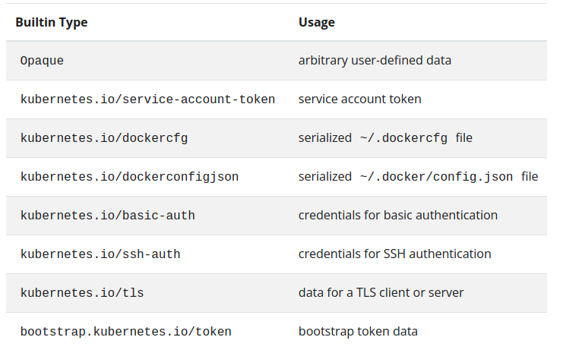
Refer https://kubernetes.io/docs/concepts/configuration/secret/ for above secret type in detail

Opaque secrets
Opaque is the default Secret type if omitted from a Secret configuration file. When you create a Secret using kubectl, you will use the generic subcommand to indicate an Opaque Secret type. For example, the following command creates an empty Secret of type Opaque.
kubectl create secret generic empty-secret
kubectl get secret empty-secret

Managing Resources for Containers
When you specify a Pod, you can optionally specify how much of each resource a Container needs. The most common resources to specify are CPU and memory (RAM); there are others.
When you specify the resource request for Containers in a Pod, the scheduler uses this information to decide which node to place the Pod on. When you specify a resource limit for a Container, the kubelet enforces those limits so that the running container is not allowed to use more of that resource than the limit you set. The kubelet also reserves at least the request amount of that system resource specifically for that container to use.
Request – minimum resources required to run the container
limit – Maximum resources required by container. If limit isn’t set then the container can try to use more RAM
Each Container of a Pod can specify one or more of the following:
- spec.containers[].resources.limits.cpu
- spec.containers[].resources.limits.memory
- spec.containers[].resources.limits.hugepages-<size>
- spec.containers[].resources.requests.cpu
- spec.containers[].resources.requests.memory
- spec.containers[].resources.requests.hugepages-<size>
apiVersion: v1
kind: Pod
metadata:
name: frontend
spec:
containers:
- name: app
image: images.my-company.example/app:v4
resources:
requests:
memory: "64Mi"
cpu: "250m"
limits:
memory: "128Mi"
cpu: "500m"
- name: log-aggregator
image: images.my-company.example/log-aggregator:v6
resources:
requests:
memory: "64Mi"
cpu: "250m"
limits:
memory: "128Mi"
cpu: "500m"

Organizing Cluster Access Using kubeconfig Files
Use kubeconfig files to organize information about clusters, users, namespaces, and authentication mechanisms. The kubectl command-line tool uses kubeconfig files to find the information it needs to choose a cluster and communicate with the API server of a cluster.
By default, kubectl looks for a file named config in the $HOME/.kube directory
kubectl config view

Security
https://kubernetes.io/docs/concepts/security/overview/

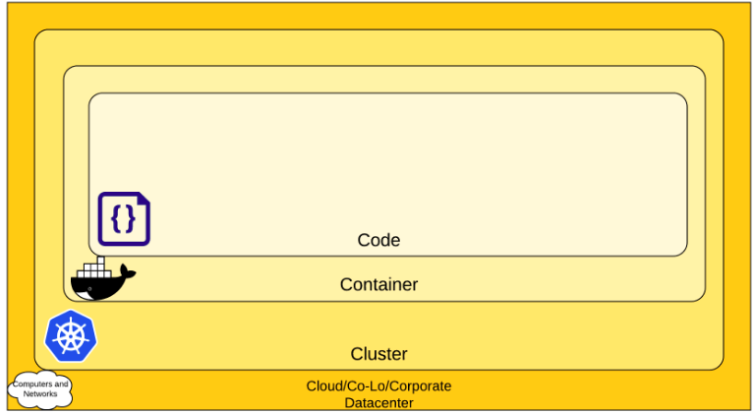
Scheduling, Preemption & eviction

Assigning Pod to Node
You can constrain a Pod so that it can only run on particular set of Node(s). There are several ways to do this and the recommended approaches all use label selectors to facilitate the selection.

Node Selector
nodeSelector is the simplest recommended form of node selection constraint. nodeSelector is a field of PodSpec. It specifies a map of key-value pairs. For the pod to be eligible to run on a node, the node must have each of the indicated key-value pairs as labels (it can have additional labels as well). The most common usage is one key-value pair.
k get nodes -> List of nodes in cluster
kubectl label nodes <NODE_NAME> disktype=<DESIRED_NAME> -> Add label to nodes
kubectl get nodes --show-labels -> Display node’s label

apiVersion: v1
kind: Pod
metadata:
name: nginx
labels:
env: test
spec:
containers:
- name: nginx
image: nginx
imagePullPolicy: IfNotPresent
nodeSelector:
disktype: ssd
When you then run kubectl apply -f https://k8s.io/examples/pods/pod-nginx.yaml, the Pod will get scheduled on the node that you attached the label to. You can verify that it worked by running kubectl get pods -o wide and looking at the "NODE" that the Pod was assigned to.

Node affinity
Node affinity is conceptually similar to nodeSelector -- it allows you to constrain which nodes your pod is eligible to be scheduled on, based on labels on the node.
There are currently two types of node affinity, called requiredDuringSchedulingIgnoredDuringExecution and preferredDuringSchedulingIgnoredDuringExecution. You can think of them as "hard" and "soft" respectively, in the sense that the former specifies rules that must be met for a pod to be scheduled onto a node
apiVersion: v1
kind: Pod
metadata:
name: with-node-affinity
spec:
affinity:
nodeAffinity:
requiredDuringSchedulingIgnoredDuringExecution:
nodeSelectorTerms:
- matchExpressions:
- key: kubernetes.io/e2e-az-name
operator: In
values:
- e2e-az1
- e2e-az2
preferredDuringSchedulingIgnoredDuringExecution:
- weight: 1
preference:
matchExpressions:
- key: another-node-label-key
operator: In
values:
- another-node-label-value
containers:
- name: with-node-affinity
image: k8s.gcr.io/pause:2.0

Inter-pod affinity and anti-affinity
Inter-pod affinity and anti-affinity allow you to constrain which nodes your pod is eligible to be scheduled based on labels on pods that are already running on the node rather than based on labels on nodes.
Inter-pod affinity and anti-affinity require substantial amount of processing which can slow down scheduling in large clusters significantly. We do not recommend using them in clusters larger than several hundred nodes.
apiVersion: v1
kind: Pod
metadata:
name: with-pod-affinity
spec:
affinity:
podAffinity:
requiredDuringSchedulingIgnoredDuringExecution:
- labelSelector:
matchExpressions:
- key: security
operator: In
values:
- S1
topologyKey: topology.kubernetes.io/zone
podAntiAffinity:
preferredDuringSchedulingIgnoredDuringExecution:
- weight: 100
podAffinityTerm:
labelSelector:
matchExpressions:
- key: security
operator: In
values:
- S2
topologyKey: topology.kubernetes.io/zone
containers:
- name: with-pod-affinity
image: k8s.gcr.io/pause:2.0

Pod Overhead
When you run a Pod on a Node, the Pod itself takes an amount of system resources. These resources are additional to the resources needed to run the container(s) inside the Pod. Pod Overhead is a feature for accounting for the resources consumed by the Pod infrastructure on top of the container requests & limits.
To use the PodOverhead feature, you need a RuntimeClass that defines the overhead field. As an example, you could use the following RuntimeClass definition with a virtualizing container runtime that uses around 120MiB per Pod for the virtual machine and the guest OS:
kind: RuntimeClass
apiVersion: node.k8s.io/v1
metadata:
name: kata-fc
handler: kata-fc
overhead:
podFixed:
memory: "120Mi"
cpu: "250m"
Workloads which are created which specify the kata-fc RuntimeClass handler will take the memory and cpu overheads into account for resource quota calculations, node scheduling, as well as Pod cgroup sizing.
apiVersion: v1
kind: Pod
metadata:
name: test-pod
spec:
runtimeClassName: kata-fc
containers:
- name: busybox-ctr
image: busybox
stdin: true
tty: true
resources:
limits:
cpu: 500m
memory: 100Mi
- name: nginx-ctr
image: nginx
resources:
limits:
cpu: 1500m
memory: 100Mi

Pod Disruption Budget(PDB)
A Kubernetes administrator can create a deployment of a kind: PodDisruptionBudget for high availability of the application, it makes sure that the minimum number is running pods are respected as mentioned by the attribute minAvailable spec file. This is useful while performing a drain where the drain will halt until the PDB is respected to ensure the High Availability(HA) of the application. The following spec file also shows minAvailable as 2 which implies the minimum number of an available pod (even after the election).
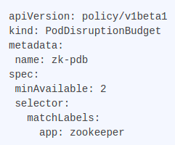

Taints and Tolerations
Node affinity is a property of Pods that attracts them to a set of nodes (either as a preference or a hard requirement). Taints are the opposite -- they allow a node to repel a set of pods.
Tolerations are applied to pods, and allow (but do not require) the pods to schedule onto nodes with matching taints.
Taints and tolerations work together to ensure that pods are not scheduled onto inappropriate nodes. One or more taints are applied to a node; this marks that the node should not accept any pods that do not tolerate the taints.
Add taint:
kubectl taint nodes node1 key1=value1:NoSchedule
Remove Taint:
kubectl taint nodes node1 key1=value1:NoSchedule-

You specify a toleration for a pod in the PodSpec. Both of the following tolerations "match" the taint created by the kubectl taint line above, and thus a pod with either toleration would be able to schedule onto node1:

tolerations:
- key: "key1"
operator: "Equal"
value: "value1"
effect: "NoSchedule"

tolerations:
- key: "key1"
operator: "Exists"
effect: "NoSchedule"

apiVersion: v1
kind: Pod
metadata:
name: nginx
labels:
env: test
spec:
containers:
- name: nginx
image: nginx
imagePullPolicy: IfNotPresent
tolerations:
- key: "example-key"
operator: "Exists"
effect: "NoSchedule"

kubectl taint nodes node1 key1=value1:NoSchedule
kubectl taint nodes node1 key1=value1:NoExecute
kubectl taint nodes node1 key2=value2:NoSchedule

tolerations:
- key: "key1"
operator: "Equal"
value: "value1"
effect: "NoSchedule"
- key: "key1"
operator: "Equal"
value: "value1"
effect: "NoExecute"
tolerationSeconds: 3600

In this case, the pod will not be able to schedule onto the node, because there is no toleration matching the third taint.

Taint Based Evictions
https://kubernetes.io/docs/concepts/scheduling-eviction/taint-and-toleration/#taint-based-evictions
The NoExecute taint effect, mentioned above, affects pods that are already running on the node as follows
- pods that do not tolerate the taint are evicted immediately
- pods that tolerate the taint without specifying tolerationSeconds in their toleration specification remain bound forever
- pods that tolerate the taint with a specified tolerationSeconds remain bound for the specified amount of time

However, a toleration with NoExecute effect can specify an optional tolerationSeconds field that dictates how long the pod will stay bound to the node after the taint is added.

Node-pressure Eviction
https://kubernetes.io/docs/concepts/scheduling-eviction/node-pressure-eviction/

Cluster administration
https://kubernetes.io/docs/concepts/cluster-administration

Logging Architecture
Native functionality provided by a container engine or runtime is usually not enough for a complete logging solution. For example, you may want access your application's logs if a container crashes; a pod gets evicted; or a node dies. In a cluster, logs should have a separate storage and lifecycle independent of nodes, pods, or containers. This concept is called cluster-level logging.
https://kubernetes.io/docs/concepts/cluster-administration/logging/

System metrics
https://kubernetes.io/docs/concepts/cluster-administration/system-metrics/

Safely Drain a Node
You can use kubectl drain to safely evict all of your pods from a node before you perform maintenance on the node (e.g. kernel upgrade, hardware maintenance, etc.). Safe evictions allow the pod's containers to gracefully terminate and will respect the Pod Disruption Budget(PDB) you have specified.

Ingress
https://kubernetes.io/docs/concepts/services-networking/ingress/

Ingress vs NodePort vs Load Balancers
https://platform9.com/blog/ultimate-guide-to-kubernetes-ingress-controllers/
Ingress exposes HTTP and HTTPS routes from outside the cluster to services within the cluster. Traffic routing is controlled by rules defined on the Ingress resource.
An Ingress may be configured to give Services externally-reachable URLs, load balance traffic, terminate SSL / TLS, and offer name-based virtual hosting. An Ingress controller is responsible for fulfilling the Ingress, usually with a load balancer, though it may also configure your edge router or additional frontends to help handle the traffic.
Exposing services other than HTTP and HTTPS to the internet typically uses a service of type Service.Type=NodePort or Service.Type=LoadBalancer.
Ingress Controller: https://kubernetes.io/docs/concepts/services-networking/ingress-controllers/
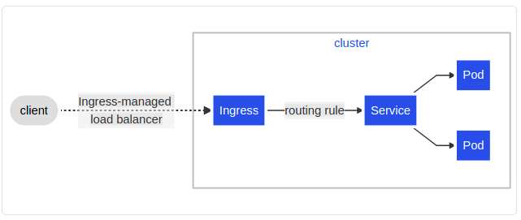
A backend is a combination of Service and port names as described in the Service doc or a custom resource backend by way of a CRD. HTTP (and HTTPS) requests to the Ingress that matches the host and path of the rule are sent to the listed backend.
apiVersion: networking.k8s.io/v1
kind: Ingress
metadata:
name: ingress-wildcard-host
spec:
rules:
- host: "foo.bar.com"
http:
paths:
- pathType: Prefix
path: "/bar"
backend:
service:
name: service1
port:
number: 80
- host: "*.foo.com"
http:
paths:
- pathType: Prefix
path: "/foo"
backend:
service:
name: service2
port:
number: 80

Types of Ingress

Ingress backed by a single Service
There are existing Kubernetes concepts that allow you to expose a single Service (see alternatives). You can also do this with an Ingress by specifying a default backend with no rules Where is the IP allocated by the Ingress controller to satisfy this Ingress.
apiVersion: networking.k8s.io/v1
kind: Ingress
metadata:
name: test-ingress
spec:
defaultBackend:
service:
name: test
port:
number: 80

Simple fanout
A fanout configuration routes traffic from a single IP address to more than one Service, based on the HTTP URI being requested. An Ingress allows you to keep the number of load balancers down to a minimum. For example, a setup like:

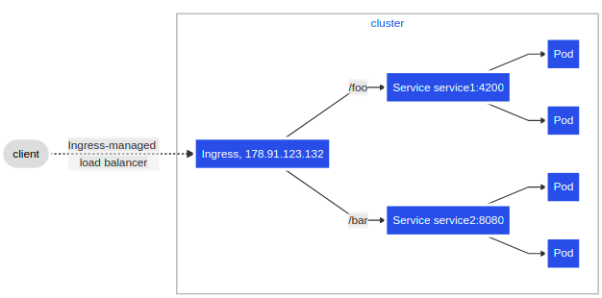
apiVersion: networking.k8s.io/v1
kind: Ingress
metadata:
name: simple-fanout-example
spec:
rules:
- host: foo.bar.com
http:
paths:
- path: /foo
pathType: Prefix
backend:
service:
name: service1
port:
number: 4200
- path: /bar
pathType: Prefix
backend:
service:
name: service2
port:
number: 8080

Name based virtual hosting
Name-based virtual hosts support routing HTTP traffic to multiple host names at the same IP address.
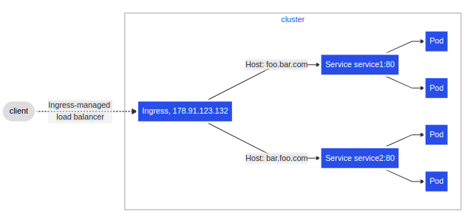
apiVersion: networking.k8s.io/v1
kind: Ingress
metadata:
name: name-virtual-host-ingress
spec:
rules:
- host: foo.bar.com
http:
paths:
- pathType: Prefix
path: "/"
backend:
service:
name: service1
port:
number: 80
- host: bar.foo.com
http:
paths:
- pathType: Prefix
path: "/"
backend:
service:
name: service2
port:
number: 80

Kustomization
https://kubernetes.io/docs/tasks/manage-kubernetes-objects/kustomization/
kubectl kustomize ./ - Display the output after applying kustomization

configMapGenerator
To generate a ConfigMap from a file, add an entry to the files list in configMapGenerator. Here is an example of generating a ConfigMap with a data item from a .properties file:
# Create a application.properties file
cat <<EOF >application.properties
FOO=Bar
EOF

cat <<EOF >./kustomization.yaml
configMapGenerator:
- name: example-configmap-1
files:
- application.properties
EOF

secretGenerator
You can generate Secrets from files or literal key-value pairs. To generate a Secret from a file, add an entry to the files list in secretGenerator. Here is an example of generating a Secret with a data item from a file:
# Create a password.txt file
cat <<EOF >./password.txt
username=admin
password=secret
EOF

cat <<EOF >./kustomization.yaml
secretGenerator:
- name: example-secret-1
files:
- password.txt
EOF

generatorOptions
The generated ConfigMaps and Secrets have a content hash suffix appended. This ensures that a new ConfigMap or Secret is generated when the contents are changed. To disable the behavior of appending a suffix, one can use generatorOptions. Besides that, it is also possible to specify cross-cutting options for generated ConfigMaps and Secrets.
Refer: /home/vinoth/Learning/Kubernetes/Projects/kubernetes/Kustomize
config name: example-configmap-1-f85b2dkd4h
cat <<EOF >./kustomization.yaml
configMapGenerator:
- name: example-configmap-3
literals:
- FOO=Bar
generatorOptions:
disableNameSuffixHash: true
labels:
type: generated
annotations:
note: generated
EOF

Setting cross-cutting fields
It is quite common to set cross-cutting fields for all Kubernetes resources in a project. Some use cases for setting cross-cutting fields:
- setting the same namespace for all Resources
- adding the same name prefix or suffix
- adding the same set of labels
- adding the same set of annotations

cat <<EOF >./kustomization.yaml
namespace: my-namespace
namePrefix: dev-
nameSuffix: "-001"
commonLabels:
app: bingo
commonAnnotations:
oncallPager: 800-555-1212
resources:
- deployment.yaml
EOF

Composing and Customizing Resources

Composing
Kustomize supports composition of different resources. The resources field, in the kustomization.yaml file, defines the list of resources to include in a configuration. Set the path to a resource's configuration file in the resources list
cat <<EOF >./kustomization.yaml
resources:
- deployment.yaml
- service.yaml
EOF

Customizing
Patches can be used to apply different customizations to Resources. Kustomize supports different patching mechanisms through patchesStrategicMerge and patchesJson6902. patchesStrategicMerge is a list of file paths
# Create a patch increase_replicas.yaml
cat <<EOF > increase_replicas.yaml
apiVersion: apps/v1
kind: Deployment
metadata:
name: my-nginx
spec:
replicas: 3
EOF

# Create another patch set_memory.yaml
cat <<EOF > set_memory.yaml
apiVersion: apps/v1
kind: Deployment
metadata:
name: my-nginx
spec:
template:
spec:
containers:
- name: my-nginx
resources:
limits:
memory: 512Mi
EOF

cat <<EOF >./kustomization.yaml
resources:
- deployment.yaml
patchesStrategicMerge:
- increase_replicas.yaml
- set_memory.yaml
EOF

In addition to patches, Kustomize also offers customizing container images or injecting field values from other objects into containers without creating patches
cat <<EOF >./kustomization.yaml
resources:
- deployment.yaml
images:
- name: nginx
newName: my.image.registry/nginx
newTag: 1.4.0
EOF

Vars
Sometimes, the application running in a Pod may need to use configuration values from other objects. For example, a Pod from a Deployment object need to read the corresponding Service name from Env or as a command argument. Since the Service name may change as namePrefix or nameSuffix is added in the kustomization.yaml file. It is not recommended to hard code the Service name in the command argument. For this usage, Kustomize can inject the Service name into containers through vars.

cat <<EOF > deployment.yaml
apiVersion: apps/v1
kind: Deployment
metadata:
name: my-nginx
spec:
selector:
matchLabels:
run: my-nginx
replicas: 2
template:
metadata:
labels:
run: my-nginx
spec:
containers:
- name: my-nginx
image: nginx
command: ["start", "--host", "$(MY_SERVICE_NAME)"]
EOF
cat <<EOF >./kustomization.yaml
namePrefix: dev-
nameSuffix: "-001"

resources:
- deployment.yaml
- service.yaml

vars:
- name: MY_SERVICE_NAME
objref:
kind: Service
name: my-nginx
apiVersion: v1
EOF

Bases and Overlays
Kustomize has the concepts of bases and overlays. A base is a directory with a kustomization.yaml, which contains a set of resources and associated customization. A base could be either a local directory or a directory from a remote repo, as long as a kustomization.yaml is present inside. An overlay is a directory with a kustomization.yaml that refers to other kustomization directories as its bases. A base has no knowledge of an overlay and can be used in multiple overlays. An overlay may have multiple bases and it composes all resources from bases and may also have customization on top of them.
kubectl kustomize ./ - Display the output after applying kustomization
kubectl apply -k ./ - Apply customization & run it
kubectl delete -k ./ - delete
kubectl describe -k ./
kubectl diff -k ./ - compare the Deployment object dev-my-nginx against the state that the cluster would be in if the manifest was applied.

Get a Shell to a Running Container
apiVersion: v1
kind: Pod
metadata:
name: shell-demo
spec:
volumes:
- name: shared-data
emptyDir: {}
containers:
- name: nginx
image: nginx
volumeMounts:
- name: shared-data
mountPath: /usr/share/nginx/html
hostNetwork: true
dnsPolicy: Default

kubectl exec --stdin --tty shell-demo -- /bin/bash
kubectl exec shell-demo env --> environment variable
Experiment with running other commands. Here are some examples:
kubectl exec shell-demo -- ps aux
kubectl exec shell-demo -- ls /
kubectl exec shell-demo -- cat /proc/1/mounts
kubectl exec -i -t my-pod --container main-app -- /bin/bash --> more than 1 container.

Logging

ELK Stack
https://github.com/vinothg2309/Microservices/tree/main/ELK

The ELK stack is an acronym used to describe a stack that comprises of three popular projects: Elasticsearch, Logstash, and Kibana.
Elasticsearch – Store the data
Logstash – Process the data
Kibana – UI to view the data

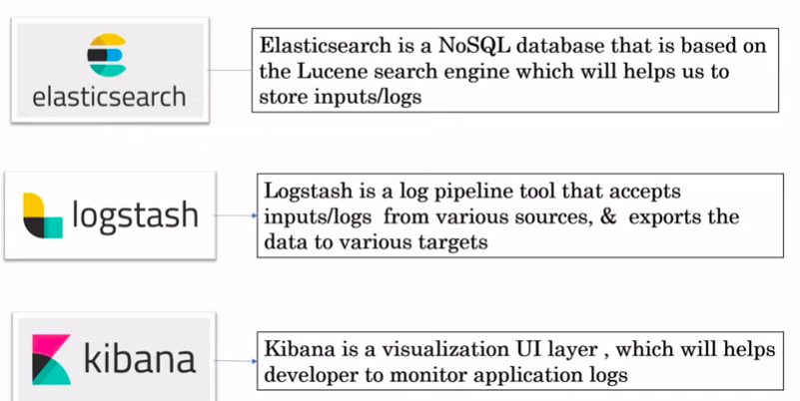
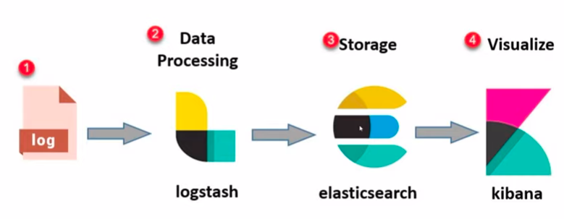
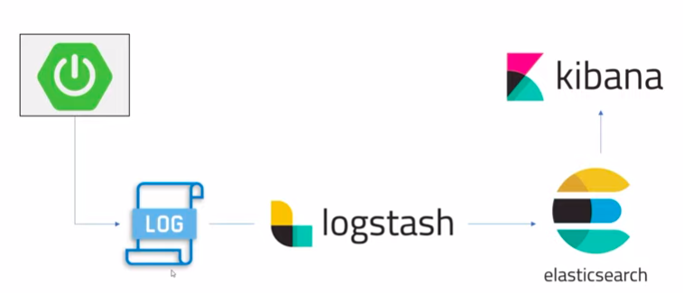
Authentication
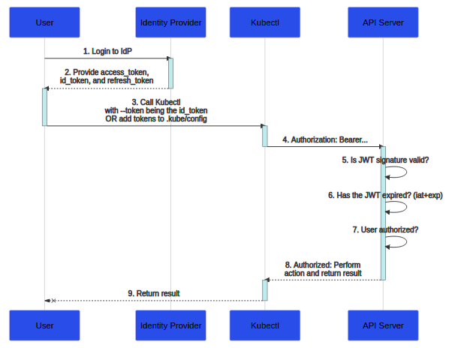
Login to your identity provider
- Your identity provider will provide you with an access_token, id_token and a refresh_token
- When using kubectl, use your id_token with the --token flag or add it directly to your kubeconfig
- kubectl sends your id_token in a header called Authorization to the API server
- The API server will make sure the JWT signature is valid by checking against the certificate named in the configuration
- Check to make sure the id_token hasn't expired
- Make sure the user is authorized
- Once authorized the API server returns a response to kubectl
- kubectl provides feedback to the user
It does offer a few challenges:
- Kubernetes has no "web interface" to trigger the authentication process. There is no browser or interface to collect credentials which is why you need to authenticate to your identity provider first.
- The id_token can't be revoked, it's like a certificate so it should be short-lived (only a few minutes) so it can be very annoying to have to get a new token every few minutes.
- To authenticate to the Kubernetes dashboard, you must use the kubectl proxy command or a reverse proxy that injects the id_token.

Helm
https://phoenixnap.com/kb/helm-commands-cheat-sheet
INSTANCE_NAME – IN, HELM_CHART_PATH - HCP
CMD | Action
helm create employee-helm  helm create <folder_name> | create helm chart folder inside the app with list of helm template
helm template test ./helm-chart/  helm template <IN> <HCP> | Apply helm values, chart.yaml & create actual k8s yaml files
helm template emp ./helm-chart/ > helm-generated.yaml  helm template <IN> ./<HCP> helm-generated.yaml | Apply helm values, chart.yaml & create actual k8s yaml files is generated to yaml file
helm install emp-service <HELM_FOLDER> | Apply the helm changes & run it in k8s cluster
helm install <INSTANCE> <HELM_FOLDER> --values <VALUES.yaml path> | Run it after updating new release in Values yaml.
helm lint <HELM_PATH> | Validate the chart.
Helm install –-dry-run –-debug <HELM_PATH> --generate_name | Validate & display t actual yaml
Helm -h | List of all commands in helm
Helm list | Running helm details

To Do:
Helm dependencies
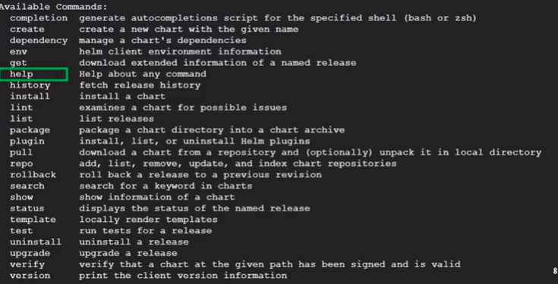

Built in objects
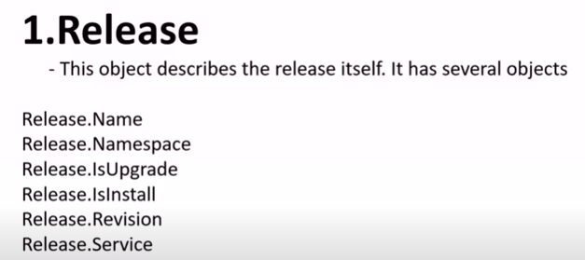
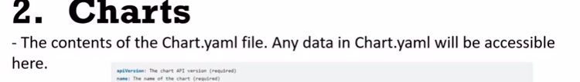

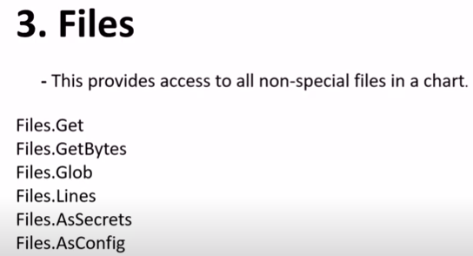

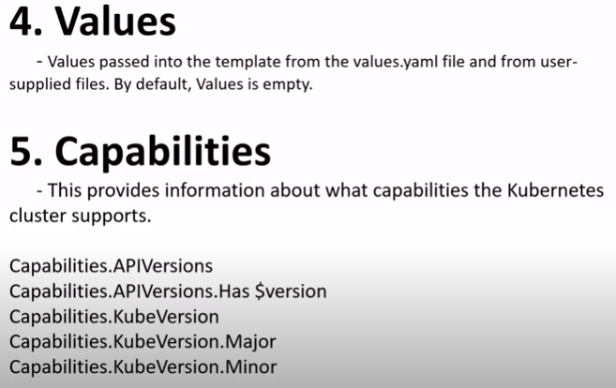

Cluster Management
https://www.youtube.com/watch?v=QyG0WSCszYg

Service Account(SA)
https://medium.com/the-programmer/working-with-service-account-in-kubernetes-df129cb4d1cc
Kubectl get serviceaccount(sa)
kubectl get serviceaccount -A – List all service accounts
k describe sa <SA_NAME> -n <namespace>
There are two types of account in Kubernetes
User Account: It is used to allow us, humans, to access the given Kubernetes cluster. Any user needs to get authenticated by the API server to do so. A user account can be an admin or a developer who is trying to access the cluster level resources.
Service Account: It is used to authenticate machine level processes to get access to our Kubernetes cluster. The API server is responsible for such authentication to the processes running in the pod

Cluster Role
Kubectl get clusterrole
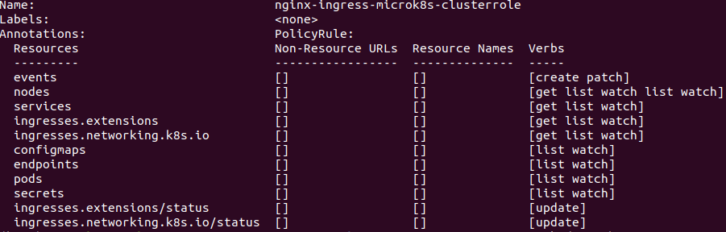
k describe clusterrole <CR>
We can see different privileges for each object in verbs column
Role – user access to specific namespace
Cluster Role – For application security for all namespace
ServiceAccount – may (or) may not be namespace specific, Cluster Role - not specific to namespace, Cluster Role Binding – Linking service account & cluster role
